# Assignment submission 010 Element (MOD005246)

SID: 205707

Date: 4th November 2021

# **Eager beavers**

After an absence of 400 years beavers (Castor fiber) are back in Britain.  Hunted to extinction for fur, meat, and secretions (castoreum), beavers disappeared from Britain by the end of the 16th century, but now they are being reintroduced across the UK.

Beavers are a 'keystone' species and are arch ecosystem engineers and this has been a prime motivation for reintroductions especially given the success of programmes across Europe, as well as increased interest in restoring native species.

Beavers are exclusive herbivores, eating bark, rhizomes, leaves and twigs, with a particular predilection for willow. A recent review by Brazier et al identified myriad ways in which beavers impact their environment including (Brazier et al., 2021):

* Building dams and channels which slow water flow and help control flooding, and help create wetlands
* Creating ponds which provide habitat for plants and other species, and are nutrient rich and protect beavers from predators
* Harvesting trees for dam building and food which has a 'coppicing' effect on understorey growth
* Improving water quality
* Creation of new habitat

Taken together the evidence strongly suggests that beavers provide a wide range of valuable ecosystem services and increase biodiversity. As well as increasing biodiversity, beaver engineering of water systems may help mitigate against flooding caused by extreme rain events, and generated pools and dams capture carbon and create carbon sinks through the accumulation of sediment and new plant growth.

.

## **Scottish Beaver Trial**

This longest running reintroduction programme in Britain is the Scottish Beaver Trial which began in 2008 in Knapdale Forest with the release of 16 beavers from Norway. The project was inspired by the success of reintroduction programmes across Europe where the beaver had historically suffered a similar fate to that in Britain and was long in the gestation – first being mooted in the 1990s.

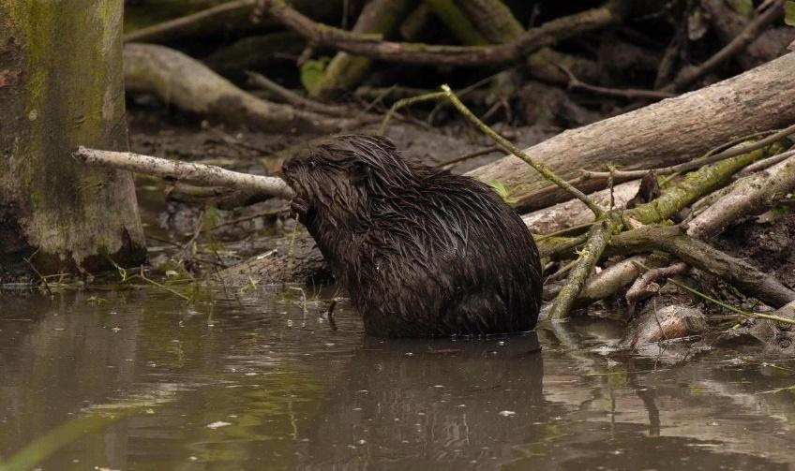

*Beaver and dam at Spain's Hall Estate, Essex.  Julian Flowers*

## **River Otter Beaver Trial**

In 2014, wild beavers were found living on the River Otter in Devon presumably having escaped from captivity. After careful work, DEFRA was persuaded to support a trial rather than recapturing them to return to captivity. This has been extensively studies culminating in

## **2021 – the year of the beaver**

There are now numerous proposed or live reintroductions across the country and 2021 has been a particularly active year.

* Derbyshire Wildlife Trust – beavers were introduced on its Willington Wetlands Nature reserve in September 2021
* Ham Fen, Kent where there are now 10 beavers following a release in 2001
* Welsh Beaver project – spring 2021 release at the Cors Dyfi reserve in Montgomeryshire
* Cornwall Beaver project – 2017 release near Truro
* Cheshire – Hatchmere nature reserve in 2020
* Dorset - 2 beavers released in 2021 in West Dorset
* Cumbria – 2 beavers released in the Lake District in 2020
* Essex – introduction of beavers as part of a natural flood management plan at Spain’s Hall Estate to protect the village of Finchingfield

In all it is estimated that there are now nearly 200 beavers in Britain.

## **Beavers and humans**

Despite initial concerns beaver-human interactions seem largely positive. Reintroduction projects are creating eco-tourism and fundraising opportunities and engaging local people through media and social media campaigns.

Beavers must be introduced under licence (Schedule 9 of the Wildlfie and Countryside Act 1981).

A recent review by Natural England in lieu of a national consultation concluded that across a wide range of habitat and species, beaver reintroduction was likely to promote increased diversity but for some groups more research was needed. There is potential for conflict where beavers create territories which impinge on low lying arable farms on flood plains but some of these issues are anticipated and addressed in the Beaver Management Handbook.

It’s not all plain sailing however – although beaver are required to be introduced into enclosed environments, they have proved adept at escaping and the Scotland experience demonstrates they can establish wild, free-living populations and they can create issues for farmers and impact native tree species.

## **What next?**

There are now several hundred beavers across the UK and DEFRA are now consulting on beaver reintroduction in England.

<https://consult.defra.gov.uk/natural-environment-policy/beaver-reintroduction-and-management/>

Beavers are back and they may be coming to a location near you…

# Ecosystem services: should health improvement be the fifth service?

*Ecosystems services* broadly means the benefits people derive from nature. Human health benefits derive from many of these services. Although human health improvement is not explicitly named as a category of ecosystem service, many of the benefits like regulation of air or water quality are directly health protecting and provision of food or therapeutics are clearly directly essential for human health and wellbeing. However, there is a growing evidence base of direct human health benefits of nature and taken together with growing public awareness of these benefits I argue that health improvement should be considered as a separate ecosystem service and ecologists and public health practitioners have common ground which can be mutually beneficial.

## What are ecosystem services?

Ecosystem services are defined as the “benefits people derive from ecosystems”. There are 4 types of service conventionally referred to as: -

* *provisioning* for example, food, fuel, and timber
* *regulating* including carbon capture and storage, water and air purification, pollination, and pest control
* *supporting* services like habitat provision and
* *cultural* services which include spiritual, recreational, educational, and therapeutic benefits.

The rationale for ecosystem services is to provide a framework for quantifying the benefits of nature and conservation.

## Ecosystem services and human health improvement

Public health is concerned with health protection and health improvement. Health protection largely refers to controlling the spread of communicable diseases and protection from environmental health hazards, whereas health improvement is concerned with general wellbeing and longevity. Because ecosystem services are defined in an anthropocentric way, some ecosystem services map to human health benefits. For example, provision of food and medicines clearly has health benefit; improving air and water quality, flood protection and carbon capture are health protecting; cultural benefits contribute to human wellbeing.

However, there is a growing evidence base linking direct health benefits to human contact with nature and greenspace. Whilst ‘greenspace’ and ‘nature` are not directly synonymous, a major review of reviews (<https://beyondgreenspace.net/2020/07/29/improving-access-to-greenspace-a-new-review-for-2020/>) found both physical and mental health improvement from direct contact with green space. These benefits manifest as improved quality of life, better mental wellbeing and lower levels of depression and anxiety in young people, and higher levels of self-reported mental health across all age groups. Another dimension of this research is that wellbeing benefits (in the UK at least) are greatest for the most disadvantaged groups in society. In short, getting out into nature is good for human health, particularly mental wellbeing.

## Goin’ up the country

This is of relevance in the COVID19 era. Data from *Our World in Data* using Google Community Mobility Trends shows just how much more people have been accessing greenspace in the UK (parks and the countryside) across the course of the pandemic. Although exacerbated by lockdowns, this effect has persisted, as other sectors have recovered.

## Growing public interest

There is also a growing public interest in nature and the environment which COVID and climate change concerns have accelerated. There are cultural trends like *shinrin yoku (*forest bathing) promoting the wellbeing benefits of being out amongst the trees, public attitude surveys show increased concern and awareness of nature and conservation, and our major political parties reflect this in policies for nature and the environment.

## Health improvement: A fifth ecosystem service?

Given the increasing evidence for direct human health benefits from exposure to nature and the growing interest in green issues I believe there is an opportunity to forge stronger partnerships between ecologists and conservationists, public health practitioners, and the public to promote the health benefits of nature and argue that human health improvement is an ecosystem service. There is considerable common ground.

Health improvement as a consequence of greenspace can be valued and quantified and if incorporated into ecosystem service audits can lend weight to conservation arguments and contribute to conservation policy.